Microservices with Spring Boot 3 and Spring Cloud

## Creating Microservices for account and loan

## Account Microservice

AccountController.java

package com.cognizant.controller;

import java.util.HashMap;

import java.util.Map;

import org.springframework.web.bind.annotation.GetMapping;

import org.springframework.web.bind.annotation.PathVariable;

import org.springframework.web.bind.annotation.RequestMapping;

import org.springframework.web.bind.annotation.RestController;

*@RestController*

*@RequestMapping*("/accounts")

public class AccountController {

*@GetMapping*("/{number}")

public Map<String, Object> getAccount(*@PathVariable* String number){

Map<String, Object> response=new HashMap<>();

response.put("number", number);

response.put("type", "savings");

response.put("balance", 243243);

return response;

}

}

AccountApplication.java

package com.cognizant;

import org.springframework.boot.SpringApplication;

import org.springframework.boot.autoconfigure.SpringBootApplication;

*@SpringBootApplication*

public class AccountApplication {

public static void main(String[] args) {

SpringApplication.*run*(AccountApplication.class, args);

}

}

Output:

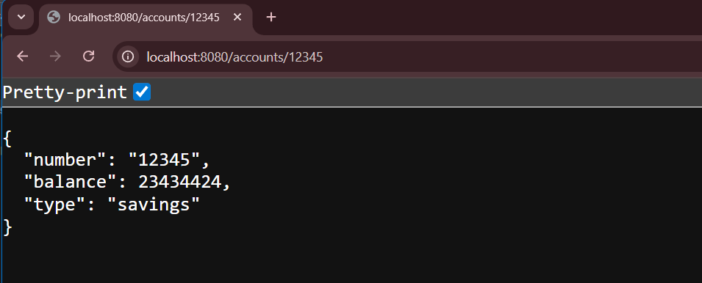

## Loan Microservice

LoanController.java

package com.cognizant.controller;

import java.util.HashMap;

import java.util.Map;

import org.springframework.web.bind.annotation.GetMapping;

import org.springframework.web.bind.annotation.PathVariable;

import org.springframework.web.bind.annotation.RequestMapping;

import org.springframework.web.bind.annotation.RestController;

*@RestController*

*@RequestMapping*("/loans")

public class LoanController {

*@GetMapping*("/{number}")

public Map<String,Object> getLoans(*@PathVariable* String number){

Map<String,Object> response=new HashMap<>();

response.put("number",number);

response.put("type", "car");

response.put("loan",40000);

response.put("emi", 3218);

response.put("tenure", 18);

return response;

}

}

LoanApplication.java

package com.cognizant;

import org.springframework.boot.SpringApplication;

import org.springframework.boot.autoconfigure.SpringBootApplication;

*@SpringBootApplication*

public class LoanApplication {

public static void main(String[] args) {

SpringApplication.*run*(LoanApplication.class, args);

}

}

Output:

